**Greeting Service**

**package** com;

**import** org.springframework.http.MediaType;

**import** org.springframework.web.bind.annotation.RequestMapping;

**import** org.springframework.web.bind.annotation.RequestParam;

**import** org.springframework.web.bind.annotation.ResponseBody;

**import** org.springframework.web.bind.annotation.RestController;

@RestController

**public** **class** GreetingApp {

@RequestMapping(path="/message", produces=MediaType.***TEXT_PLAIN_VALUE***)

@ResponseBody

**public** String processForm(@RequestParam(defaultValue="Guest") String name,

@RequestParam(required = **false**) String value) {

System.***out***.println("value"+value);

String greet1="";

**if** (value == **null**)

{

greet1="checkiton";

}

**else**

{

greet1="welcome";

}

String greet="Hello";

**return** String.*format*("%s %s %s!", greet, name,greet1);

}

}

**Output**

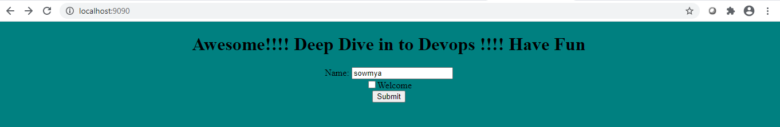

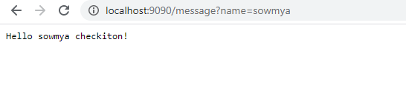

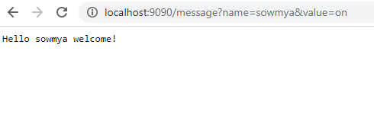

**TestCases**

**package** com;

**import** org.junit.jupiter.api.Assertions;

**import** org.junit.jupiter.api.Test;

**import** org.junit.jupiter.api.extension.ExtendWith;

**import** org.springframework.boot.test.context.SpringBootTest;

**import** org.springframework.test.context.junit.jupiter.SpringExtension;

@ExtendWith(SpringExtension.**class**)

@SpringBootTest

**public** **class** TestGreeting {

GreetingApp ga =**new** GreetingApp();

@Test

**public** **void** testcheck_empty()

{

Assertions.*assertEquals*("Hello Sowmya welcome!",ga.processForm("Sowmya",""));

}

@Test

**public** **void** testcheck_on()

{

Assertions.*assertEquals*("Hello Sowmya welcome!",ga.processForm("Sowmya","on"));

}

@Test

**public** **void** testcheck_null()

{

Assertions.*assertEquals*("Hello Sowmya checkiton!",ga.processForm("Sowmya",**null**));

}

}